

*Downton C of E VA Primary school curriculum reading spine*

|  |  |
| --- | --- |
| **EYFS** | **Core Texts and Old Favourites** |
| **Autumn term** |  |
| **Spring term** |  |
| **Summer term** |  |

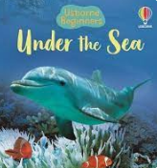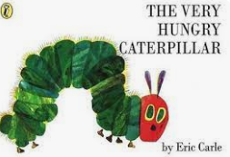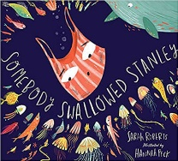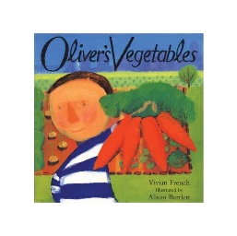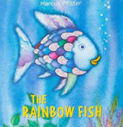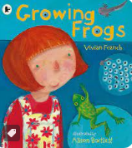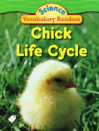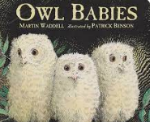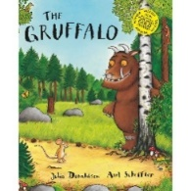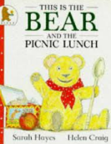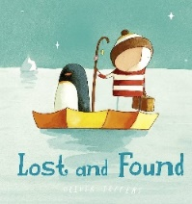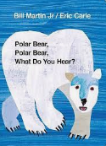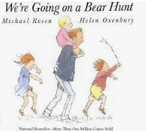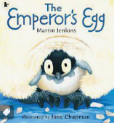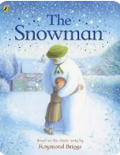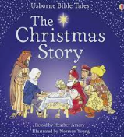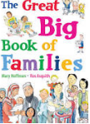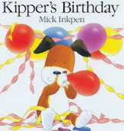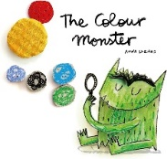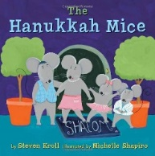

Somebody Swallowed Stanley

Rainbow Fish

Under the Sea

Oliver’s Vegetables

Growing Frogs

The Very Hungry Caterpillar

Owl Babies

The Gruffalo

The Snowman

Lost and Found

Polar Bear, Polar Bear

This is the Bear and the Picnic Lunch

We’re Going on a Bear Hunt

The Christmas Story

The Colour Monster

The Great Big Book of Families

The Hanukkah Mice

Kipper’s Birthday

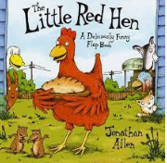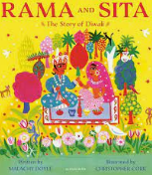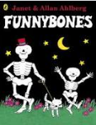

The Little Red Hen

Rama and Sita

Funny Bones

Room on the Broom

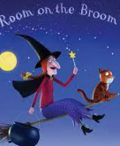

The Emperor’s Egg

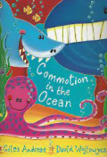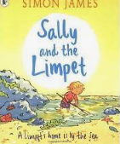

Sally and the Limpet

Commotion in the Ocean

A Stroll through the Seasons

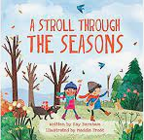

Chick Life Cycles

|  |  |  |  |
| --- | --- | --- | --- |
| **Downton CE Primary SchoolKS1 (Year 1/2)**  Children will also use poems from their class poetry book within their English lessons and Guided reading.  *Downton C of E VA Primary school curriculum reading spine* | **Core English texts- Guided reading** | **Core English texts- Writing** | **Class read** |
| **Autumn term** | Year 2: Kate and the beanstalk/ Jack and the jelly beanstalk/ The true story of the 3 little pigs/ The 3 little pigs and the big, bad book/ There is no dragon in this story  The Three Little Pigs and the Big Bad BookThe True Story of the Three Little Pigs | https://images-na.ssl-images-amazon.com/images/I/51bB-iQvvEL._SY430_BO1,204,203,200_.jpgJack and the BeanstalkJack and the Beanstalk/ Jack and the Baked Bean stalk  The three little pigs/ The 3 little wolves and the big bad pig  Three Little Wolves And The Big Bad PigC:\Users\edunford\AppData\Local\Microsoft\Windows\INetCache\Content.MSO\D124EF26.tmp | Class Poetry book  Diary of a Christmas elf  How to train your dragon |
| **Spring term** | Year 2: Doug’s Deep sea Diary/ Look up!/Africa is not a country/ Handa’s hen/ Bringing the rain to Kapiti Plain  Bringing the Rain to Kapiti PlainHanda's HenAfrica is Not a CountryLook Up!Dougal's Deep-sea Diary (Bartram, Simon Series)  The giraffe the Pelly and me (Year 2 advanced text)  The Giraffe and the Pelly and Me by Roald Dahl - a classic Roald Dahl book for 6 year olds | Bob the Man on The Moon  Man on the Moon (A Day in the Life of Bob) | Centre for Literacy in Primary  Education  Handa’s surprise/ Meerkat Mail  Handa's SurpriseMeerkat Mail | The tales of Olga da Polga  Esio Trot |
| **Summer term** | Year 2: Little people big dreams Florence Nightingale/ Lights on Cotton rock/ Traction Man/ Biscuit bear/Tad  Traction Man Is Here (Traction Man, 1)    The Owl who was afraid of the dark (Year 2 advanced text) | Vlad and the Florence Nightingale adventure/ Little people big dreams Florence Nightingale    C:\Users\edunford\AppData\Local\Microsoft\Windows\INetCache\Content.MSO\5D649758.tmpThe Great Explorer | Nim’s island The Famous five |

|  |  |  |
| --- | --- | --- |
| **Downton CE Primary SchoolLKS2 (Year 3/4)**  Children will also use poems from their class poetry book within their English lessons and Guided reading.  *Downton C of E VA Primary school curriculum reading spine* | **Core English texts**  Pugs of the Frozen North | **Core texts to support Topics** |
| **Autumn term** | Stig of the Dump  How to Wash a Woolly Mammoth  Stig Of The Dump by Clive King (9780141354859/Paperback) | LoveReading4KidsPugs of the Frozen North (Audio Download): Philip Reeve, Sarah McIntyre,  Charlie Sanderson, W. F. Howes Ltd: Amazon.co.uk: Audible Books & Originals | Stone Age Boy  Secrets of Stonehenge  The First Drawing |
| **Spring term** | Fantastic Mr Fox  Icarus was Ridiculous  Fantastic Mr Fox x 30 - Scholastic Shop | The Great Book of Mexico  Athena, The Story of a Goddess  Gaia, Goddess of Earth  So You Think You’ve Got it Bad? A Kid’s Life in Ancient Greece |
| **Summer term** | Roman Adventure  The Boy Who Grew Dragons  Escape to Pompeii  Escape from Pompeii - Balit, Christina: 9780805073249 - AbeBooks    The Boy who Grew Dragons | The Magnificent Book of Treasures: Ancient Rome  We Are the Romans      So You Think You’ve Got it Bad? A Kid’s Life in Ancient Roman |

|  |  |  |
| --- | --- | --- |
| **Downton CE Primary SchoolUKS2 (Year 5/6)**  Children will also use poems from their class poetry book within their English lessons and Guided reading.  *Downton C of E VA Primary school curriculum reading spine* | **Core English texts** | **Core texts to support Topics** |
| **Autumn term** | A Christmas Carol (with an introduction by Anthony Horowitz) by Charles  Dickens (9780141324524/Paperback) | LoveReading4Kids  A Christmas Carol  Cogheart | Queen Victoria  Eye-Witness Victorians  Street Child  Street Child x 30 - Scholastic Shop |
| **Spring term** | Letters from the Lighthouse  The Boy in the Tower    Letters from the Lighthouse x 6 - Scholastic Shop | Antarctica: The Melting Continent  Shackleton’s Journey |
| **Summer term** | A Stage Full of Shakespeare Stories  Matilda  When the Sky Falls  When the Sky Falls by Phil Earle | Waterstones | Shakespeare for Everyone  Bandoola: The Great Elephant Rescue  Skyward |